

# GRUNDY COUNTY HIGHWAY DEPARTMENT

* **Sale of Used Equipment -**

# 

**2009 Fleet Maintained Peterbilt Tandem Truck**

**Bid Opening**

**July 23, 2020**

**4:30 P.M.**

**Instruction to Bidders**

1. Bid(s) shall be made upon the form provided herein, and shall be submitted to the Grundy County Highway Department, 245 N. IL. Rt. 47, IL 60450 before 4:30p.m. on July 23, 2020, at which time they will be opened and read publicly. Bid(s) shall be submitted in a sealed envelope marked “Tandem Truck”.
2. Information is provided for each truck for sale under this bid cover. Bidders are advised that the truck is being sold “as is” with no warranty whatsoever.
3. The successful bidder (the high bidder) shall submit payment to Grundy County in the form of a certified check. Payment shall be received in the Office of the County Engineer within 24 hours of bid opening. If payment is not received by said date, Grundy County reserves the right to offer the purchase of the truck(s) to the second high bidder, or subsequent bidders as may be determined by the County Engineer.
4. Grundy County reserves the right to reject any or all bids, to waive any irregularities in the bids, and to accept in whole or in part such bid or bids as may be deemed to be in the best interest of Grundy County.
5. Upon approval of the bid by the County Engineer; and upon receipt of payment, the successful bidder may take immediate possession of the truck.

**#9**

**2009 Peterbilt Tandem**

**Mileage: 90,127**

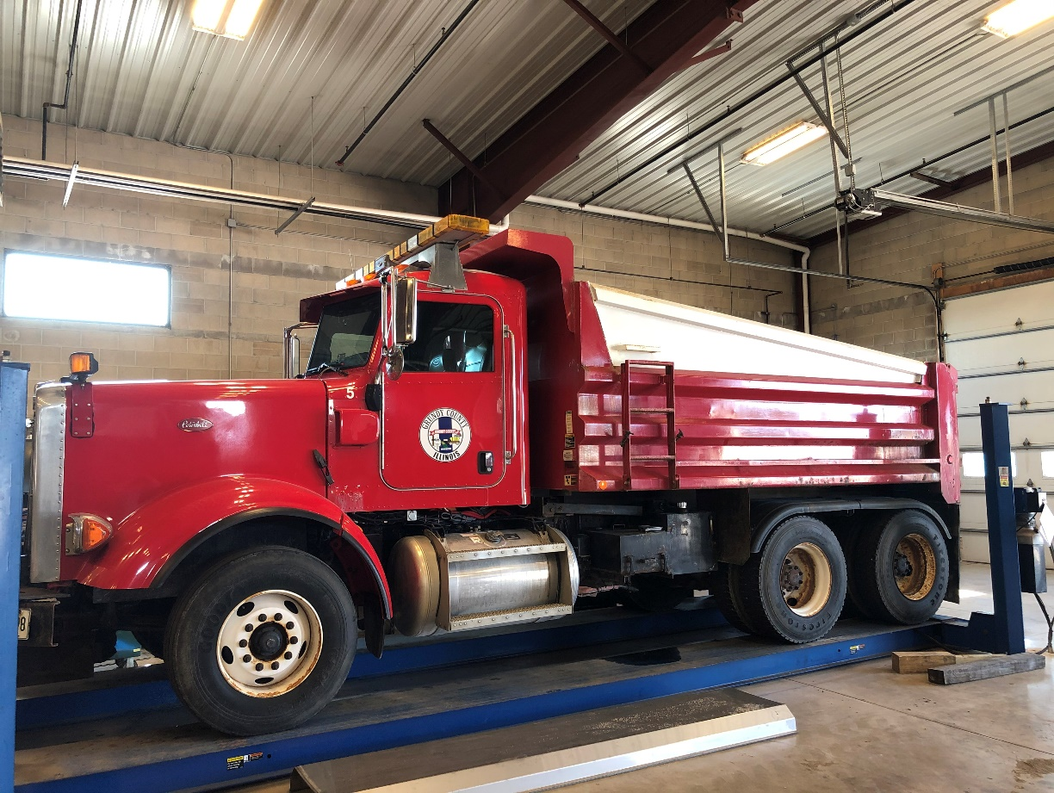

**Partial List of Equipment:**

* **4,251 Hours**
* **Cummins Engine**
* **Allison Transmission**
* **Power Windows, Door Locks, Heated Mirrors**
* **Cruise Control**
* **\*Truck Box is rusting out and will eventually need replaced or repaired**

 **GRUNDY COUNTY HIGHWAY DEPARTMENT**

245 N. IL. Rt. 47 Morris, IL. 60450 (815) 942-0363

**BID FORM**

***RETURN WITH BID IN SEALED ENVELOPE***

BID OPENING: July 23, 2020 4:30 P.M.

BID SUBMITTED BY: ____________________________________

*Name*

__________________________________________

*Address*

__________________________________________

Phone ( ______ ) _____________________

**BID**

# 2009 Peterbilt Tandem Truck: $ ____________

_________________________ ____________

Signature of Bidder Date